March 7, 2023

Video game Sales Dataset

Pretty informal Data dictionary

1. Name: Name of the video game
2. Platform: The platform where the game was released (eg. Playstation, Xbox, nintendo, etc.)
3. Year of release: the year in which the game was released
4. Genre: The theme of the game (eg. Action, adventure, sports, etc.)
5. Publisher: The company responsible for publishing the game
6. NA_Sales: The sales of the games in north America (million dollars I guess)
7. EU_Sales: the sales of the game in Europe
8. JP_Sales: The sales of the game in japan
9. Other_Sales: The sales of the game in other regions
10. Global_Sales: The sales of the game across the world
11. Critic_Score: The average score given to the game by professional critics
12. Critic_Count: The number of critics who reviewed the game
13. User_Score: The average score given to the game by users
14. User_Count: The number of users who reviewed the game
15. Developer: The company responsible for developing the game
16. Rating: The official rating of the game (Not sure what the data in this column means 🙁 Providing the chart for an idea )

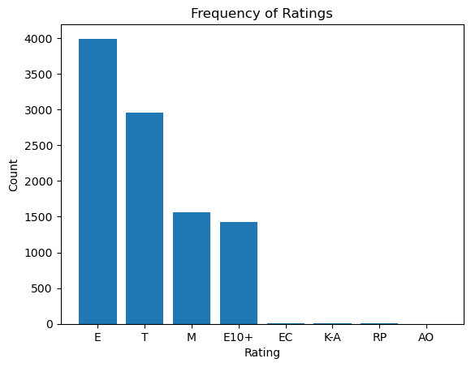

Lol I found something

